Draft 1:

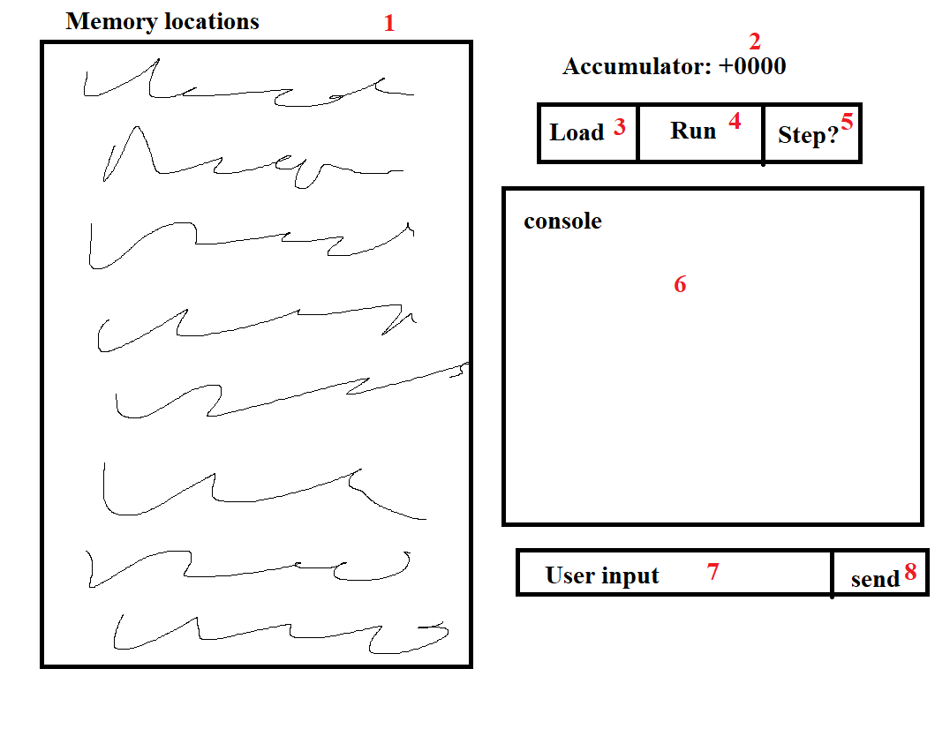

1. Visual memory space
2. Visual accumulator
3. Button that loads file from file dialogue
4. Button that runs the program
5. Button that steps the program (runs one command at a time)
6. Console for output to the user.
7. Text entry for the user (specifically for read method)
8. Button to allow inputting user text in the text entry

Draft 2:

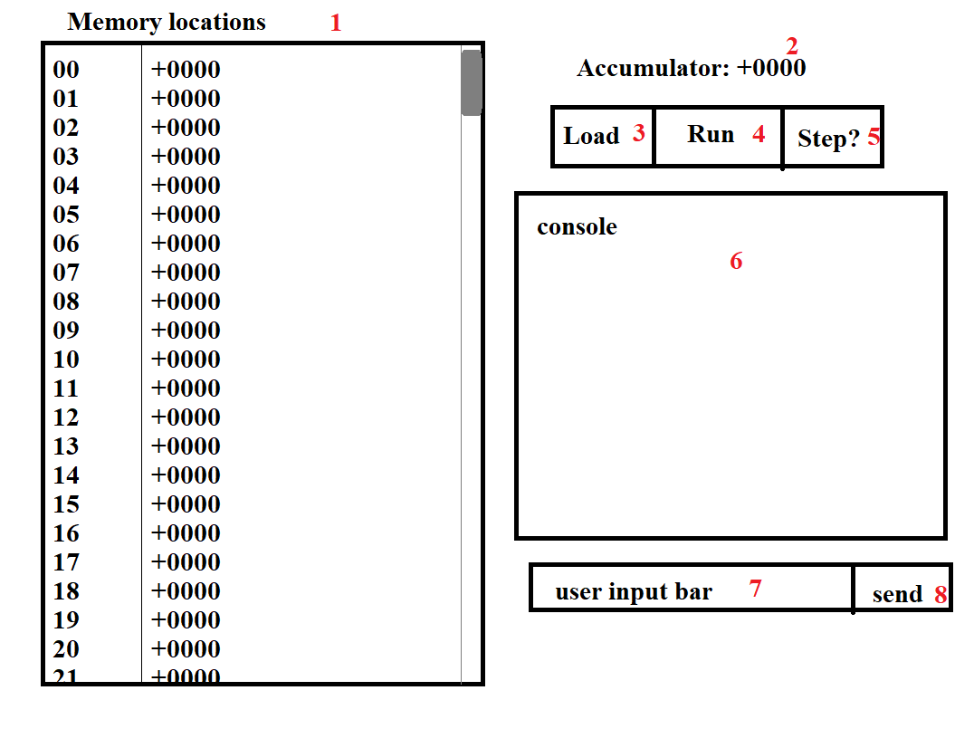

1. Visual memory space
2. Visual accumulator
3. Button that loads file from file dialogue
4. Button that runs the program
5. Button that steps the program (runs one command at a time)
6. Console for output to the user.
7. Text entry for the user (specifically for read method)
8. Button to allow inputting user text in the text entry

Final:

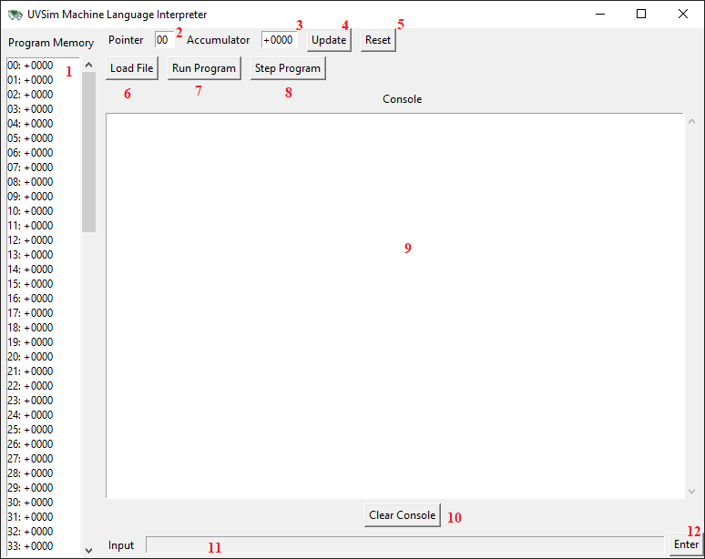

1. Visual memory space
2. Visual editable pointer
3. Visual editable accumulator
4. Button that updates accumulator and pointer based on user input
5. Button that resets the pointer and accumulator and clears the console. (Does not reset memory)
6. Button that loads file from file dialogue
7. Button that runs the program
8. Button that steps the program (runs one command at a time)
9. Console for output to the user.
10. Button that clears the console.
11. Text entry for the user (specifically for read method)
12. Button to allow inputting user text in the text entry